- Problem Statement
Given an array of 1s and 0s this has all 1s first followed by all 0s. Aim is to find the number of 0s. Write a program using Divide and Conquer to Count the number of zeroes in the given array.
Input Format
First Line Contains Integer m – Size of array
Next m lines Contains m numbers – Elements of an array
Output Format
First Line Contains Integer – Number of zeroes present in the given array.

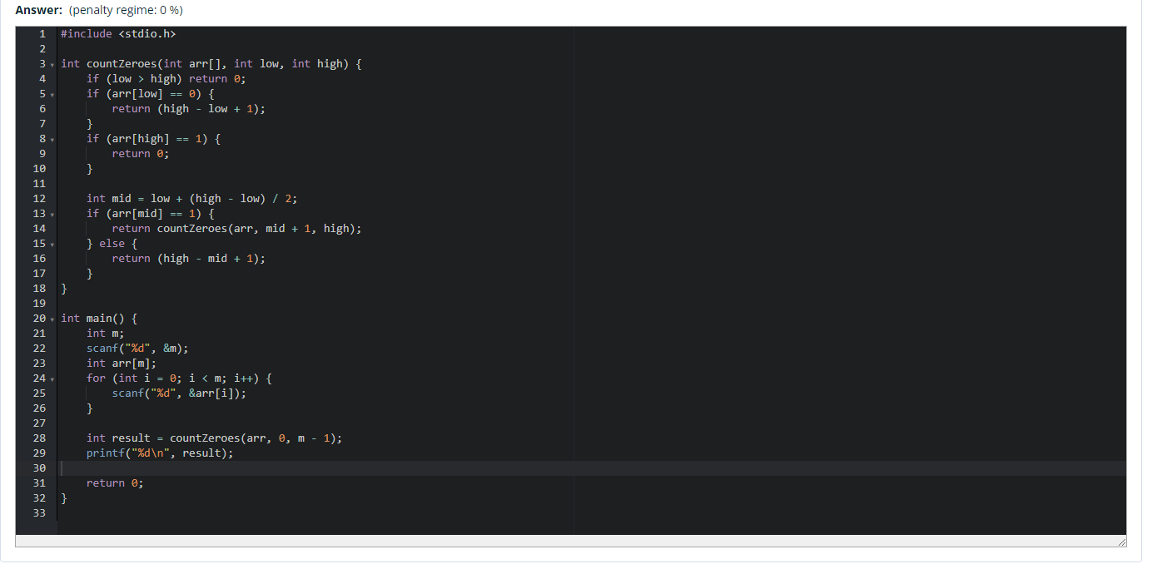
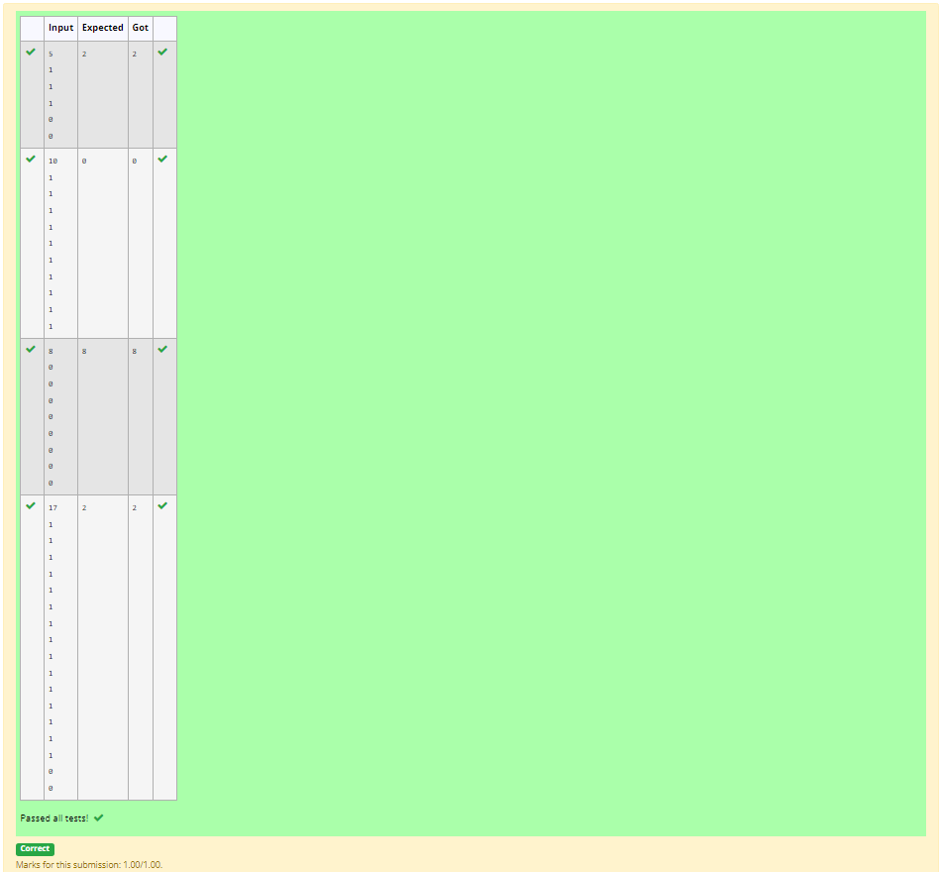

- element that appears more than ⌊n / 2⌋ times. You may assume that the majority Given an array nums of size n, return the majority element.
The majority element is the element always exists in the array.
Example 1:
Input: nums = [3,2,3]
Output: 3
Example 2:
Input: nums = [2,2,1,1,1,2,2]
Output: 2

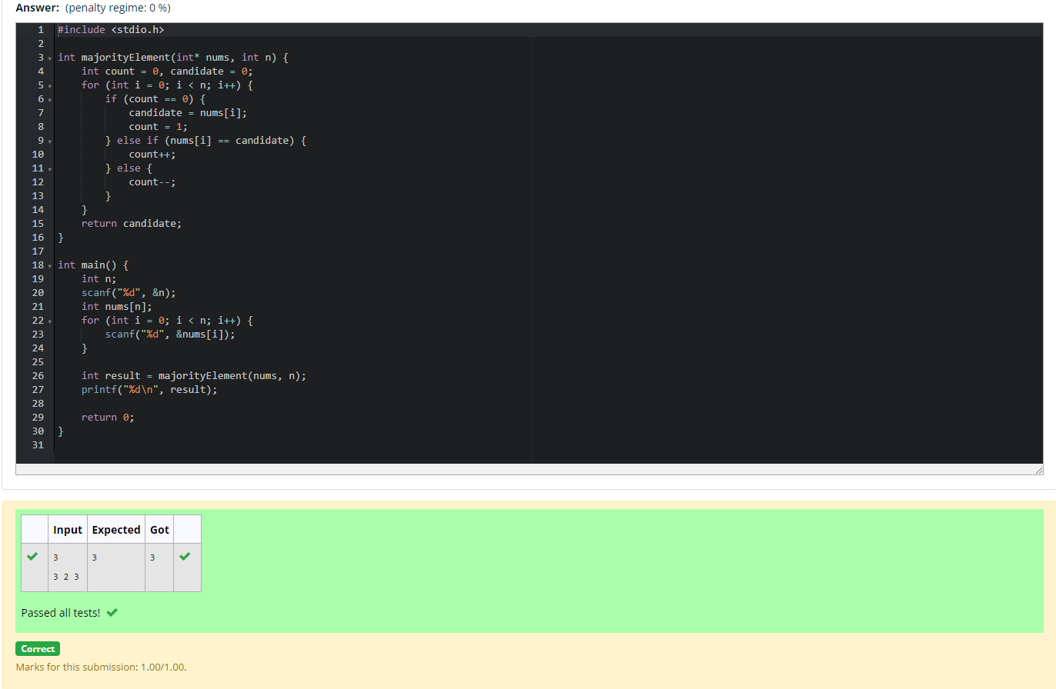

- Problem Statement:
Given a sorted array and a value x, the floor of x is the largest element in array smaller than or equal to x. Write divide and conquer algorithm to find floor of x.
Input Format
First Line Contains Integer n – Size of array
Next n lines Contains n numbers – Elements of an array
Last Line Contains Integer x – Value for x
Output Format
First Line Contains Integer – Floor value for x
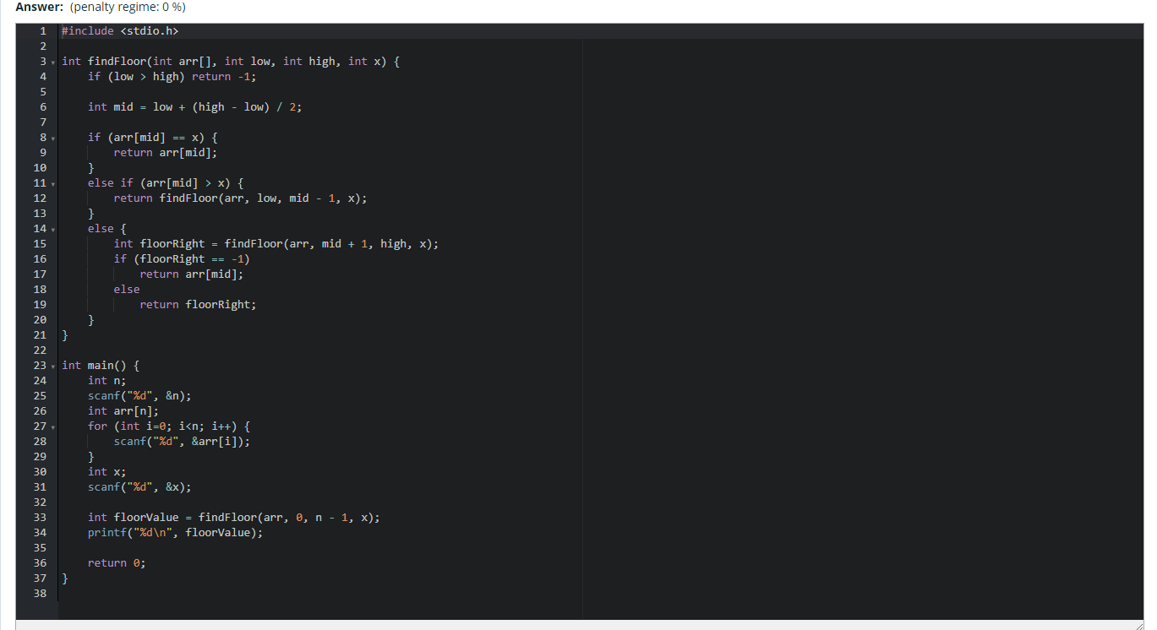
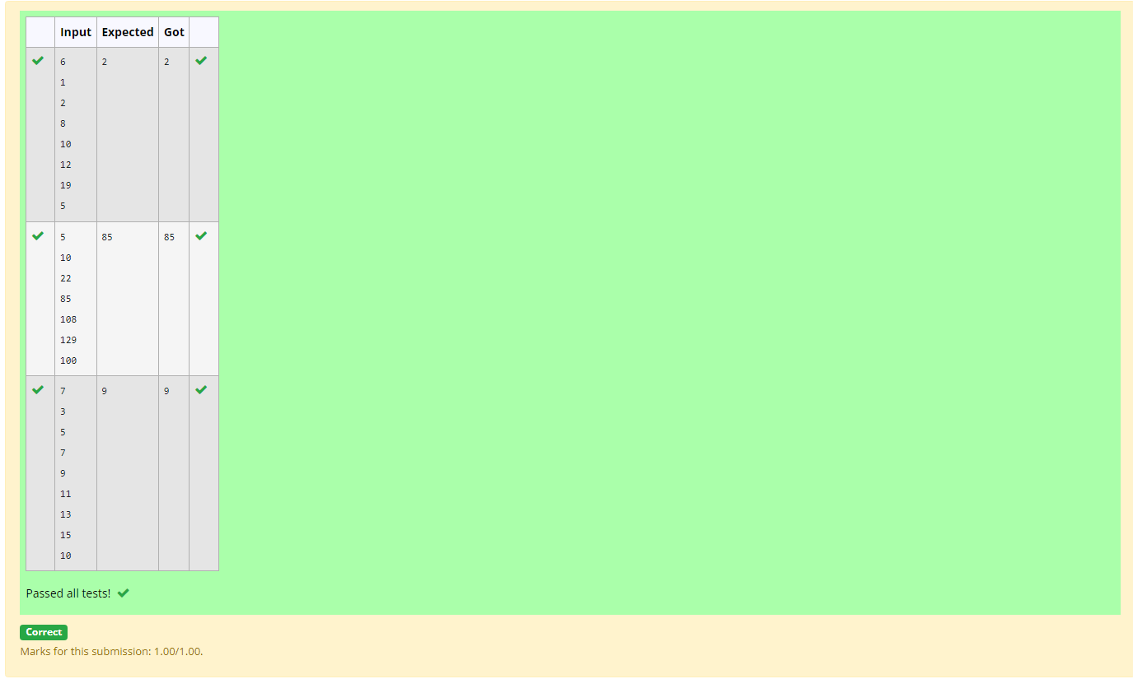

- Problem Statement:
Given a sorted array of integers say arr[] and a number x. Write a recursive program using divide and conquer strategy to check if there exist two elements in the array whose sum = x. If there exist such two elements then return the numbers, otherwise print as “No”.
Note: Write a Divide and Conquer Solution
Input Format
First Line Contains Integer n – Size of array
Next n lines Contains n numbers – Elements of an array
Last Line Contains Integer x – Sum Value
Output Format
First Line Contains Integer – Element1
Second Line Contains Integer – Element2 (Element 1 and Elements 2 together sums to value “x”)
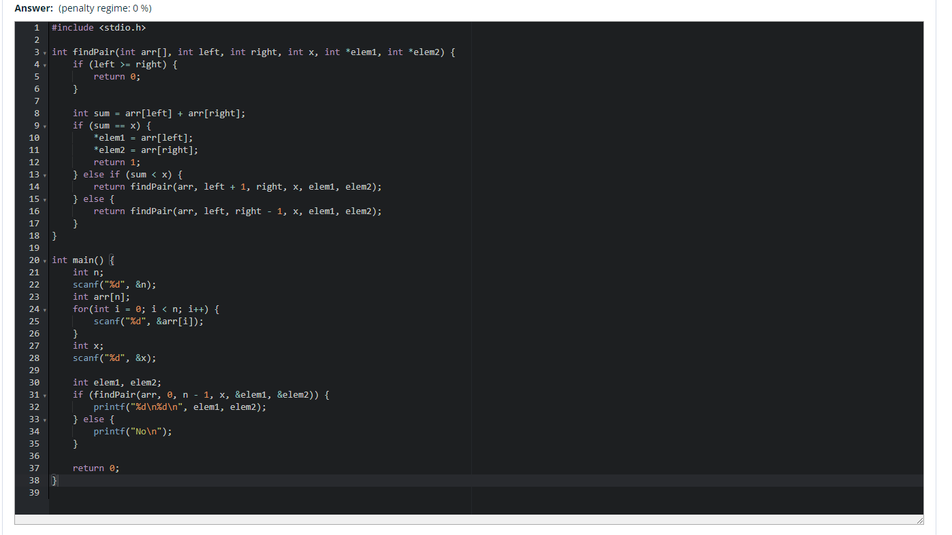

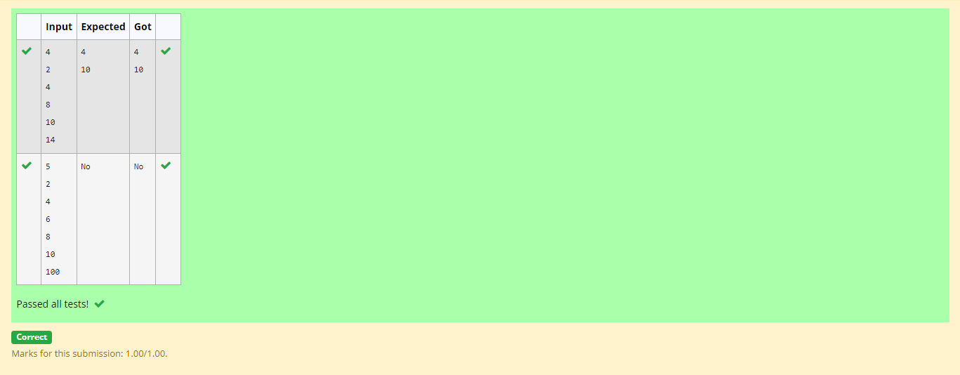

- Write a Program to Implement the Quick Sort Algorithm
Input Format:
The first line contains the no of elements in the list-n
The next n lines contain the elements.
Output:
Sorted list of elements

